# PGS

## Summary

* Estimate of individual’s genetic liability to trait or disease
  + Currently explains a small proportion of trait variance
* sum of risk alleles an individual has, weighted by risk allele effect sizes estimated by GWAS on the phenotype
* Base data: GWAS summary statistics
* Target data: genotype-phenotype data of individuals in whom PGS are calculated

## Method

[Basic Tutorial for Polygenic Risk Score Analyses (choishingwan.github.io)](https://choishingwan.github.io/PRS-Tutorial/)

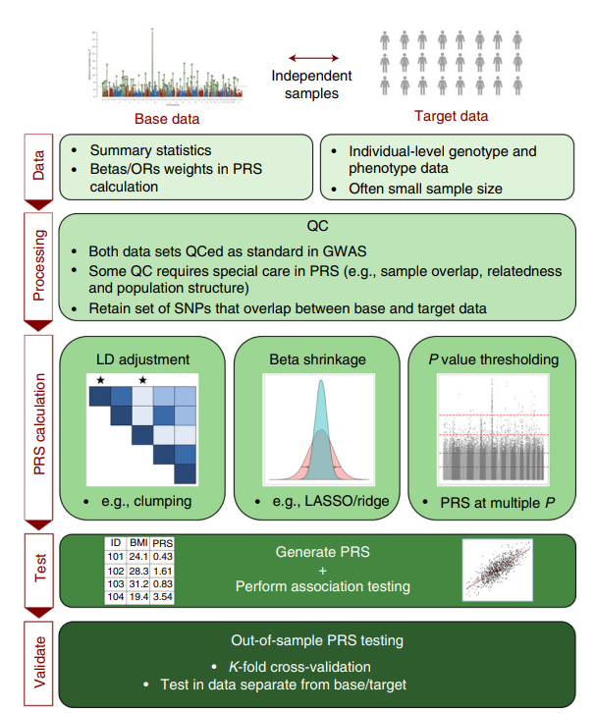

### QC for Base Data Only

1. Heritability check: use GWAS data with h^2 > 0.05
2. Effect allele: make identity of effect allele clear

### QC for Target Data Only

1. Target sample size > 100 individuals

### QC for Both Base and Target

1. Genome build: ensure base and target data SNPs have genomic positions assigned on same genome build (ex hg18)
2. Standard GWAS QC:
   1. Shing Wan Choi recommends: genotyping rate >0.99; sample missingness <0.02; HWE p>1x10^-6; heterozygosity within 3 stdev of mean; MAF >1%; info score >0.8
3. Ambiguous SNPs: remove
4. Mismatching SNPs: remove
5. Duplicate SNPs: remove
6. Sex Chromosomes: remove
7. Sample overlap:
8. Relatedness:

### Shrinkage of GWAS effect size estimates

1. Statistical shrinkage of all SNPs (ex. LASSO, ridge regression, Bayesian)
2. Clumping and thresholding (effectively shrinks all excluded SNPs to 0)
   1. Also controls for LD

### Population Structure

* Using covariates to adjust: 1st 10 PCs, birth year, and sex

### Interpret Results

* After PGSs are calculated, regression is performed on target sample
  + PGS is predictor of target trait, include covariates as appropriate
* Test for association between PGS and target trait
  + Get p-value, phenotypic variance explained (R^2), effect size estimate, etc
  + Nagelkerke R^2 estimates proportion of variance explained by PGS

## Tutorial Scripts

#### QC Target Data



#### PGS



#### PGS p-value Plot

#!/usr/bin/env Rscript

p.threshold <- c(0.001,0.05,0.1,0.2,0.3,0.4,0.5)

# Read in the phenotype file and PCs

#

setwd("~/Research/GWAS-frontera/1000G")

phenotype <- read.table("EUR.height", header=T)

pcs <- read.table("EUR.eigenvec", header=F)

setwd("~/Research/GWAS-frontera/GWAS_Results/height/PGS")

# add the appropriate headers (6 PCs)

colnames(pcs) <- c("FID", "IID", paste0("PC",1:6))

# merge the files

pheno <- merge(phenotype, pcs, by=c("FID", "IID"))

# calculate the null model (model with PGS) using a linear regression

null.model <- lm(Height~., data=pheno[,!colnames(pheno)%in%c("FID","IID")])

# R2 of the null model

null.r2 <- summary(null.model)$r.squared

PGS.result <- NULL

for(i in p.threshold){

    PGS <- read.table(paste0("EUR_female_height_PGS.",i,".profile"), header=T)

    print(head(PGS))

    # Merge PGS with phenotype matrix - only taje FID, IID and PGS

    pheno.PGS <- merge(pheno, PGS[,c("FID","IID", "SCORE")], by=c("FID", "IID"))

    # linear regression on Height with PGS and the covariates, ignoring the FID and IID

    model <- lm(Height~., data=pheno.PGS[,!colnames(pheno.PGS)%in%c("FID","IID")])

    # model R2

    model.r2 <- summary(model)$r.squared

    # R2 of PGS is simply calculated as the model R2 minus the null R2

    PGS.r2 <- model.r2-null.r2

    # We can also obtain the coeffcient and p-value of association of PGS as follow

    PGS.coef <- summary(model)$coeff["SCORE",]

    PGS.beta <- as.numeric(PGS.coef[1])

    PGS.se <- as.numeric(PGS.coef[2])

    PGS.p <- as.numeric(PGS.coef[4])

    # We can then store the results

    PGS.result <- rbind(PGS.result, data.frame(Threshold=i, R2=PGS.r2, P=PGS.p, BETA=PGS.beta,SE=PGS.se))

}

# Best result is:

print(PGS.result[which.max(PGS.result$R2),])

#### PLOT ####

library(ggplot2)

# generate a pretty format for p-value output

PGS.result$print.p <- round(PGS.result$P, digits = 3)

PGS.result$print.p[!is.na(PGS.result$print.p) &

                    PGS.result$print.p == 0] <-

    format(PGS.result$P[!is.na(PGS.result$print.p) &

                            PGS.result$print.p == 0], digits = 2)

PGS.result$print.p <- sub("e", "*x*10^", PGS.result$print.p)

# Initialize ggplot, requiring the threshold as the x-axis (use factor so that it is uniformly distributed)

ggplot(data = PGS.result, aes(x = factor(Threshold), y = R2)) +

    # Specify that we want to print p-value on top of the bars

    geom_text(

        aes(label = paste(print.p)),

        vjust = -1.5,

        hjust = 0,

        angle = 45,

        cex = 4,

        parse = T

    )  +

    # Specify the range of the plot, *1.25 to provide enough space for the p-values

    scale_y_continuous(limits = c(0, max(PGS.result$R2) * 1.25)) +

    # Specify the axis labels

    xlab(expression(italic(P) - value ~ threshold ~ (italic(P)[T]))) +

    ylab(expression(paste("PGS model fit:  ", R ^ 2))) +

    # Draw a bar plot

    geom_bar(aes(fill = -log10(P)), stat = "identity") +

    # Specify the colors

    scale_fill_gradient2(

        low = "dodgerblue",

        high = "firebrick",

        mid = "dodgerblue",

        midpoint = 1e-4,

        name = bquote(atop(-log[10] ~ model, italic(P) - value),)

    ) +

    # Some beautification of the plot

    theme_classic() + theme(

        axis.title = element_text(face = "bold", size = 18),

        axis.text = element_text(size = 14),

        legend.title = element_text(face = "bold", size =

                                        18),

        legend.text = element_text(size = 14),

        axis.text.x = element_text(angle = 45, hjust =

                                    1)

    )

# save the plot

ggsave("EUR_female.height.bar.png", height = 7, width = 7)

# Log

### 9/8/2021

* Proportion for cross-validation: 400,000 samples (both); 230,000 (female); 200,000 (male)
  + 50,000 for target: 25,000 male/female
* Age + PCs + sex (to control for M-F diff)

### 9/9/2021

* Remove 3rd degree relatives or closer; 2 options
  + Keep only ids used in genetic principal components,
  + <https://elifesciences.org/articles/48376#s4> GWAS by sample characteristics section
  + <https://biobank.ctsu.ox.ac.uk/crystal/field.cgi?id=22020> data field
  + Calculate kinship coefficients, and remove coefficients greater than 0.0442 (3rd degree) using –king-cutoff
  + <https://plink.readthedocs.io/en/latest/GWAS/> Relatives section
* Split into test and training set; for phenotype data, get 50k, 25k female, 25k male
  + Total iids in ukb: 502,491
  + Total iids in height pheno: 499952
  + Total iids in sex_ids.txt: 488249
  + **Steps**: Keep white British, remove relatives, merge on iids with sex_ids.txt, random sample 25k for each sex
* Finally, if PLINK 2 determines that any samples and covariates are irrelevant to all regressions (e.g. a covariate could be zero-valued for all but one sample), they are removed before any variants are processed. You can use the '**pheno-ids**' modifier to make PLINK 2 report the remaining samples to (per-phenotype) [.id](https://www.cog-genomics.org/plink/2.0/formats#id) files. (When the sample set changes on chrX or chrY, .x.id and/or .y.id files are also written.)

### 9/10/2021

* How –score works <https://zzz.bwh.harvard.edu/plink/profile.shtml>
  + score is simply a sum across SNPs of the number of reference alleles (0,1 or 2) at that SNP multiplied by the score for that SNP
    - score for that SNP is the effect size

### 9/22/2021

* Debug PGS step1 and step2 files
  + Step1: change to keep only pheno values in QCed samples, reformat iid file (2 columns, no header)
  + Step2: merge all QC files first, so in script, just use merge file to subset

### 9/23/2021

* New GWAS done for:
  + Height, bmi, testosterone, waist:hip bmi, waist and hip circ, waist:hip, bloodpressure, albumin, pulse rate, RBC_count, IGF1, creatinine, weight, calcium, protein, urea, SHBG, wholebodyfatmass, FVC_best, HbA1c, urate, armfatfreemass, eosinophilperc, lymphocyte perc, wthbmiadj **(all)**
* Mash setup done for: **all**
* Mash 100 done for: height, testosterone, bmi, blood pressure, urate, waist_to_hip bmi, arm_fatfree, IGF1, creatinine
* PGS step 1 (training set) done for **all** + diabetes, asthma, hypertension
* PGS step 2 (GWAS) done for
  + Height, testosterone, bmi, waist:hip bmi, arm mass, BP, whole body fat mass, IGF1, creatinine, urate, RBC_count, weight, calcium, protein_total, asthma, diabetes, hypertension
* PGS mash done for
  + Set up: height, testosterone, bmi, waist:hip bmi, arm fatfree, blood pressure, whole body fat mass, IGF1, creatinine, urate, RBC_count, weight, calcium, protein_total, asthma, diabetes, hypertension
  + 100: height, bmi, testosterone, arm_fatfree_mass R/L, waist:hip bmi; BP, urate, creatinine, IGF1, whole_body_fat_mass, protein_total, calcium, RBC_count, weight, asthma, diabetes, hypertension
  + Posterior: height, bmi, testosterone, waist_hip_bmi, arm_fatfree_mass R/L, BP, IGF1, whole body fat mass, urate, creatinine, calcium, protein total, weight, RBC_count,asthma, diabetes, hypertension
* Step 4 PGS- 1.5 hr each
  + Additive: height, bmi, testosterone, waist:hip bmi, arm_fatfree, BP, IGF1, whole_body, creatinine, urate, protein total, calcium, weight, asthma, diabetes, RBC
  + Mash: height, bmi, testosterone, waist:hip bmi, arm_fatfree, BP, IGF1, whole_body, creatinine, urate, protein total, calcium, weight, asthma, diabetes, RBC
* Update LD_groups.R file to match new variants

### 9/27/2021

* updates PGS scripts – mash v additive
* r = correlation between observed and expected
* r^2 = coefficient of determination, explained variation/total variation
* lm() produces the coefficient of determination – how good is our model

### 9/29/2021

* Why is height’s r^2 so low? Should be ~0.15-0.4
* Check Manhattan plots: looks the same as last time for both sex and same sex
* Test ids – 25k each
* Clump
  + 1,278,888 clumps

* PGS score
  + 252,461 variants from test bed and pvar file

* + Fixed – 9 mil loaded from .bim now
* Compare with BMI
  + 9,607,691 in BMI bim file!!
* Bernabeau – standing height - measure
  + Same F – 0.0531 Same M – 0.0420
  + Agnostic F – 0.0486 Agnostic M – 0.0315
* Flynn paper – sex specific genetic effects across biomarkers
  + Testosterone R^2
    - Male Same: 0.31 female Same: 0.21
    - Male Combined: 0.020 female combined: 018

### 9/31/2021

* Test PGS height models on both sex
  + Same sex additive: null: 0.5324???
    - Female -> both: 0.6093, inc 0.0769
    - Male -> both: 0.6035, inc 0.07117
  + Both sex additive: null 0.5324
    - R^2: 0.5931, inc 0.0607
* Fixed: There were half as many variants when taking out the SNPs form the training fileset for both_Sex

### 10/5/2021

* combined model (if male / if female) -> 1 reg coefficient
* why producing such a high null R^2
  + adding sex as covariate, null R^2 increase from 0.019 to 0.532 (for height additive)
    - R^2 just using sex: 0.5088
  + incremental R^2 when using sex-specific additive PGS = 0.074
  + incremental R^2 when using both-sex additive PGS = 0.101

### 10/6/2021

* urate male GWAS missing 1 SNP = rs116389124 (chr 9) – shows up as NA
  + in female: 
  + in both_sex: 
  + removed SNP in lfsr_to_pvalue script for further analysis (row 9427528) in mash_setup



* error with RBC_count lfsr to pvalue
  + male has an extra SNP – extra one in position 5587172, SNP rs113251786
  + removed that SNP to continue lfsr->pvalue
* same issue above with asthma – manually do lfsr -> pvalue

### 10/12/2021

* PGS predictions for binary traits – logistic regression and AUC
* install.packages("ROCR",lib="/work/08005/cz5959/frontera/R/x86_64-pc-linux-gnu-library/4.0/")
* library(ROCR, lib.loc="/work/08005/cz5959/frontera/R/x86_64-pc-linux-gnu-library/4.0/")
* AIC – smaller the better, penalizes increasing # of coefficients

### 10/14/2021

* NA value in height male – chr 9
  + 9427528 9 90473529 rs116389124 T G 0.843368 2.70925 0.755579
  + VEP: non coding transcript exon variant
  + Removed in mash_setup, !! remove in lfsr_to_p

### 10/20/2021

* Look at SNPs from mash – different methods (would like to use posterior distributions, but mash does not provide them)
  + Look at posterior means, 2 st dev difference between sexes
  + Look at lfsr
  + Look at posterior weights?

### 10/27/2021

* Waist:hip ratio (bmi adj) – error in 5th trial?
* Waist:hip bmi adj – missing snp, removed



* Meeting notes
  + More analysis for pheno-pgs plot
    - estimate slope in males, 2-sided hypothesis test to see if reject slope in females
    - weighted linear regression – weight = 1/(st error)squared
      * size of point can be the error term
      * like figure from slack
  + own theme for all plots – color for male and female, make it look nice
  + correlation between phenotype and pgs vs testosterone levels
    - each data point is a trait
  + figure outline for paper
  + simulation study to see if mash is capturing environmental variance

### 10/28/2021

* different gwas lengths – from mash setup
  + arm_fatfree_mass_L (3): 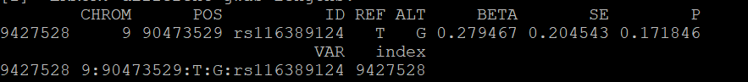
  + arm_fatfree_mass_L(4): 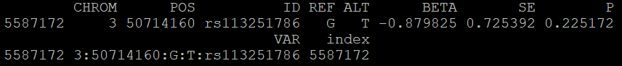
  + diastolicBP_auto(3):
  + 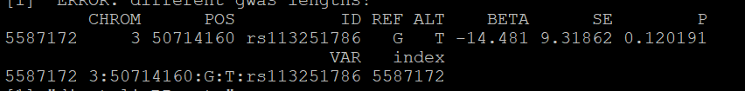
  + diastolicBP_auto(5): Text

    Description automatically generated
  + systolicBP_auto(5): 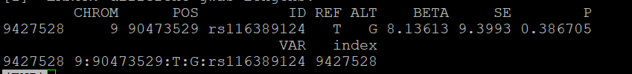
  + SHBG 1: Text

    Description automatically generated
  + FVC_best 1: 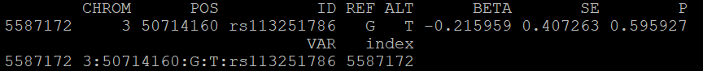
  + Waist_circ 1: 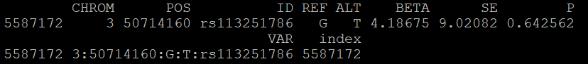
  + IGF1 3: Text

    Description automatically generated
  + HbA1c 2: 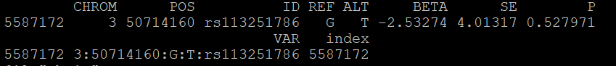
  + HbA1c 3: 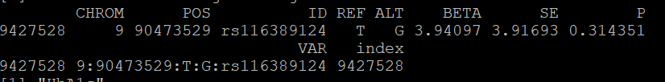
  + Urate 4: Text

    Description automatically generated

### 11/12/2021

* Do another 5 for wth_bmi_adj, PGS_testset seed(2), PGS_6-10

### 11/19/2021

* FVC_best – 5th iteration fold for PGS – ran out of samples so instead did:
  + Seed (2)